ICQSGW2026 1. Foundations & Theory

Hydrogen Fuel Cells: A Statistical Review of Applications, Socio-Economic Impacts, and Future Forecasting
S. Verma¹, A. Bansal², S. Kundrar¹, T. Sharma¹ and N. Pradhan¹

¹Department and Institute Name, Address, Place, PIN, Country
²UGC-DAE Consortium for Scientific Research, University Campus, Khandwa Road, Indore 452 001, India Email: abc@gmail.com
Hydrogen fuel cells (HFCs), which have made substantial technological strides in recent years, hold promise as alternative energy sources with high electrical efficiency and zero emissions. Currently employed across various energy sectors, HFCs are increasingly recognized for their structural and operational advantages, showing greater efficiency, durability, and adaptability with each passing year. However, there remains a need for an in-depth study of their evolving configurations, potential socio-economic impacts, and production and cost trends to fully envision the future role of HFCs.
This work aims to provide a comprehensive outlook on the future utilization and forecast of HFCs. First, it presents an analysis of upcoming HFC configurations based on fuel types, alongside the evolving landscape of hydrogen production. Next, it explores potential future applications of HFCs in key sectors, including stationary, portable, transportation, and space applications. Following this, anticipated socio-economic impacts—such as job creation, environmental benefits, and health improvements—are examined in the context of future developments. The study further clarifies implementation trends across industries like transportation, heating, industrial heat, industrial feedstock, and power generation, aligned with a vision for 2050. Finally, production and cost forecasts are presented to map out the economic feasibility of advancing HFC technologies into the future.
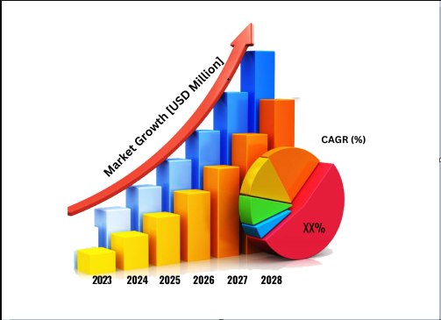

Fig.: A brief description of the above.

References:
- Verne, J.; Wyeth, N.C. The Mysterious Island; C. Scribner’s Sons: New York, NY, USA, 1920.
- Dunn, S. Hydrogen futures: Toward a sustainable energy system. Int. J. Hydrog. Energy 2002, 27, 235–264.
- K&L Gates. The H2 Handbook: Legal, Regulatory, Policy, and Commercial Issues Impacting the Future of Hydrogen; K&L Gates: Pittsburgh, PA, USA, 2020.
- IEA. The Future of Hydrogen; IEA: Paris, France, 2019.
- Bockris, J.O.M. A hydrogen economy. Science (80-) 1972, 176, 1323.

Note: Make sure to adhere to 1 page limit!

